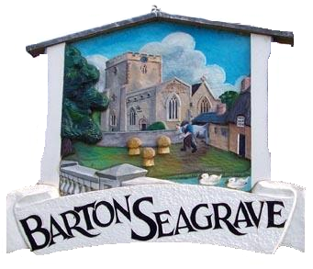
BARTON SEAGRAVE PARISH COUNCIL
Parish Clerk: Wendy Brackenbury
Barton Seagrave village Hall
11 Bertone Road
Barton Seagrave
NN15 6WF

Email: clerk@bartonseagrave-pc.gov.uk

www.bartonseagraveparishcouncil.org.uk

BARTON SEAGRAVE PARISH COUNCIL PLANNING MEETING

I hereby give notice that a planning meeting of Barton Seagrave Parish Council is to be held on Tuesday 28 April 2026 at Barton Seagrave Village Hall in Bertone Road commencing at 6.30pm.

AGENDA
26/01 Apologies
26/02 Barton Seagrave Residents: fifteen minutes allocated for queries and comments
26/03 Planning Applications:

- NK/2024/0679 - Full Planning Permission: Residential development for 46 no. dwellings with associated landscaping and parking

Location: 30-42 Cranford Road (land to rear), Barton Seagrave, NN15 5JL

